Industry-specific intelligent fire management system

(Publish data to IBM cloud)

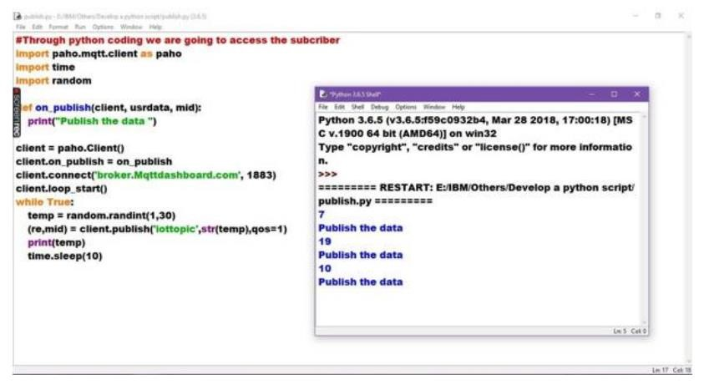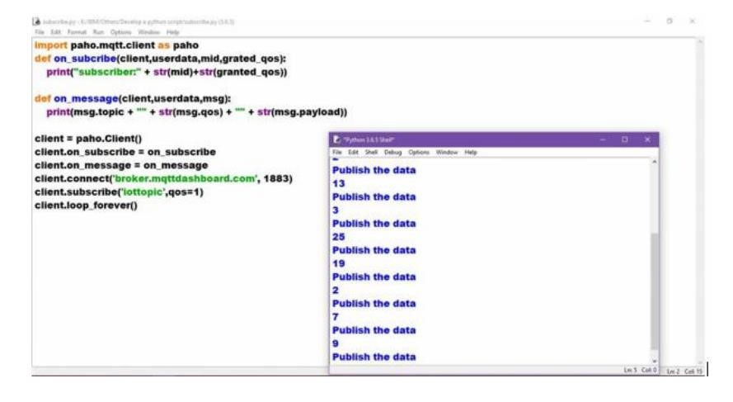

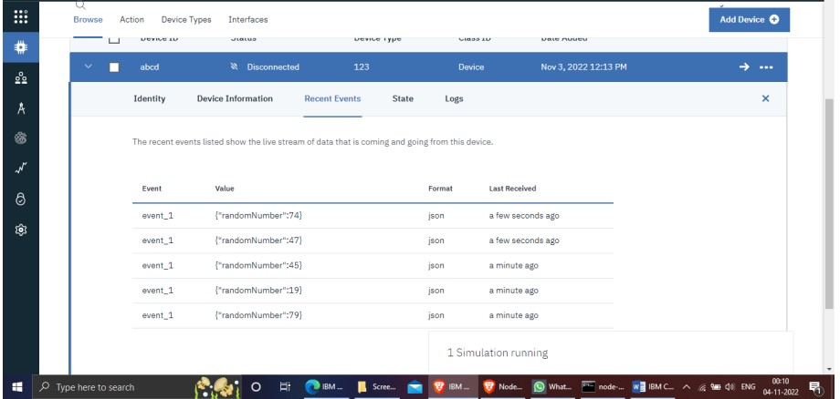

Program:

#IBM Watson IOT Platform #Pip install wiotp-sdk import wiotp.sdk.device import time import random

myConfig = {"identity": { "orgId": "hj5fmy",

"typeId": "NodeMCU",

"deviceId":"12345”},

"auth": {“token": "12345678”} } def myCommandCallback(cmd):

print ("Message received from IBM IoT Platform: %s" % cmd.data['command']) m=cmd.data['command'] client = wiotp.sdk.device.DeviceClient (config=myConfig, logHandlers=None) client.connect() while True:

temp=random.randint(-20,125) hum=random.randint(0,100) myData= {'temperature':temp, 'humidity':hum} client.publishEvent(eventId="status", msgFormat="json", data=myData, qos=0, onPublish=None) print("Published data Successfully: %s", myData) client.commandCallback = myCommandCallback

time.sleep(2) client.disconnect()